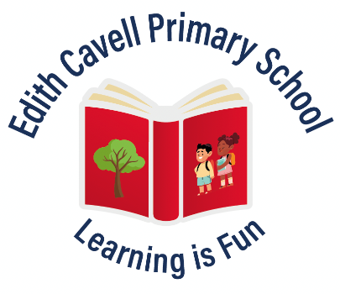
EDITH CAVELL PRIMARY SCHOOL
Manton Lane, Bedford. MK41 7NH
office@ecls.org.uk

Person Specification for Higher Level Teaching Assistant – Level 4

 | Essential | Desirable
Qualifications | - GCSE English & maths  - NVQ Level 4 or equivalent | - Educated to degree level  - First Aid qualification
Experience | - Proven sustained successful experience working with children in an educational setting within the last six months. | - Experiences working with children in EYFS, Key Stage 1 & 2  - Relevant experience in a mainstream setting
Skills / Knowledge / Aptitude | - Understanding of a variety of teaching and learning methods  - Working knowledge and experience of implementing the National Curriculum  - Knowledge of and ability to contribute to the planning and development of educational activities and resources.  - Ability to deliver learning tasks and opportunities to enable all children to access from their different starting points  - Good communication and interpersonal skills  - Good organisational and time management skills  - Ability to work collaboratively with teachers and others  - Ability to take responsibility and work with autonomy within set boundaries.  - Ability to use ICT to support learning activities  - Ability to liaise with parents and families of children.  - Willingness to be flexible  - Willing to undertake appropriate professional development  - Clear knowledge and understanding of safeguarding responsibility | - Experience in delivering learning tasks and opportunities to groups of children, a class and individuals  - Experience of using effective feedback to children to move their learning forward  - Experience in working with children with Special Educational Needs.  - Experience in delivering phonics and intervention programmes  - Experience in successfully using a variety of behaviour management strategies  - Experience in working in a highly confidential environment.  - Clear organisational skills
Application | - A well-structured, relevant and well-presented application form  - Undergo a Disclosure and Barring Check.  - Complete a pre-employment health check.
September 2025

Edith Cavell Primary School is committed to safeguarding and promoting the welfare of all children and young people and expects all staff and volunteers to share this commitment.

