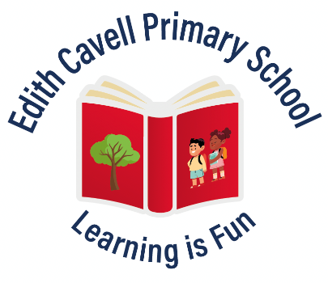
EDITH CAVELL PRIMARY SCHOOL
Manton Lane, Bedford. MK41 7NH
Ambitious, Achieving and Nurturing
Person Specification for Class Teacher
 | Essential | Desirable
Qualifications | - Qualified Teacher Status  - Educated to degree level | - Further professional qualifications  - Evidence of personal commitment to continuous professional development
Professional Knowledge and Experience | - Teaching experience across the full primary age range.  - Ability to demonstrate a good knowledge of the National Curriculum.  - Knowledge of the characteristics of effective teaching and learning.  - Experience of target setting, monitoring, assessment, recording and reporting pupil progress.  - Ability to plan and deliver differentiated lessons, where pupils are actively involved in their own learning.  - Experience in using a range of strategies to meet individual learning needs.  - Understanding of a range of Additional Educational Needs  - Knowledge of effective ways of working with parents / carers.  - Knowledge of statutory requirements of legislation concerning Equal Opportunities, Health and Safety, SEND and Child Protection. | - Experience of EYFS  - Experience of Key Stage 1 and/or Key Stage 2 Assessments and administering Key Stage 1 and/or Key Stage 2 SATs.  - Experience of teaching phonics through the Sounds Write programme.  - Experience of leading a curriculum subject across the school.  - Experience of providing extra-curricular activities.
Personal Qualities and Skills | - Demonstrate effective classroom practice and thorough planning, demanding expectations, clear targets for learning and effective use of assessment.  - Ability to use ICT for teaching, learning and personal record keeping.  - Ensure high levels of pupil interest and motivation.  - Make warm and open relationships with adults and children.  - Work as an effective team member to ensure the delivery of high quality teaching and learning.  - Promote consistent behaviour and discipline.  - Committed to safeguarding and promoting the welfare of children.  - Have good personal organization.  - Be positive, creative and energetic.  - Communicate effectively (both orally and in writing) to a variety of audiences.  - Committed to continuing professional development.  - Have a good health record. | - Knowledge of assessment for learning, use of developmental marking and feedback.  - Willing to be fully involved in the life of the school community.  - Have a good and appropriate sense of humour.
Application | - A well-structured, relevant and well-presented application form  - Undergo an Enhanced Criminal Records Bureau disclosure check.  - Complete a pre-employment health check.

