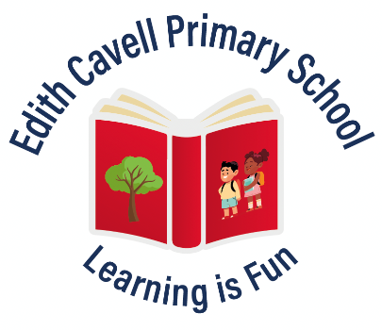
EDITH CAVELL PRIMARY SCHOOL
Manton Lane, Bedford. MK41 7NH
Ambitious, Achieving and Nurturing

Title of Post | Class teacher
Job Purpose | To support children’s learning to enable them to achieve their full potential.
Reporting to | The post holder is responsible and accountable to the Headteacher in all matters.
Main Purpose

The teacher will:
- Fulfil the professional responsibilities of a teacher, as set out in the School Teachers’ Pay and Conditions Document
- Meet the expectations set out in the Teachers’ Standards
Duties and responsibilities
Teaching
- Promote a learning environment where children are safe, happy and show consideration for others at all times so that they learn and achieve.
- Plan and teach well-structured lessons to assigned classes, following the school’s plans, curriculum and schemes of work that deliver a broad and balanced curriculum
- Assess, monitor, record and report on the learning needs, progress and achievements of assigned pupils, making accurate and productive use of assessment using relevant national and local guidelines from appropriate sources: National Curriculum, Agreed Syllabus for RE.
- Adapt teaching to respond to the strengths and needs of pupils implementing agreed school policies and schemes with particular reference to the following: teaching and learning, health and safety, safeguarding, child protection, marking and feedback, equality plan, SEND, EAL, assessment, behaviour and rewards.
- Set high expectations which inspire, motivate and challenge pupils and encourage independence in learning
- Promote good progress and outcomes by pupils
- Demonstrate good subject and curriculum knowledge
- Participate in arrangements for preparing pupils for external tests
Whole-school organisation, strategy and development
- Maintain appropriate records of attendance, progress, development and attainment in line with the school’s policies.
- Contribute to the development, implementation and evaluation of the school’s policies, practices and procedures, so as to support the school’s values and vision
- Make a positive contribution to the wider life and ethos of the school
- Work with others on curriculum and pupil development to secure co-ordinated outcomes
- Provide cover, in the unforeseen circumstance that another teacher is unable to teach or carry out break duty
Health, safety and discipline
- Promote the safety and wellbeing of pupils
- Maintain good order and discipline among pupils, managing behaviour effectively to ensure a good and safe learning environment through implementing the school’s behaviour policy consistently and fairly.
- Adhere to the “Keeping Children Safe in Education 2023” document
Professional development
- Take part in the school’s appraisal procedures
- Take part in further training and development in order to improve own practice
- Where appropriate, take part in the appraisal and professional development of others
Communication
- Create an atmosphere of trust and co-operation between home and school by working and effectively communicating with pupils, parents and carers.
- Provide an annual report to parents and attend parent consultation meetings as required
Working with colleagues and other relevant professionals
- Attend and participate fully in staff, teacher and phase meetings.
- Show good preparation when reviewing learning at Pupil Progress Meetings
- Collaborate and work with colleagues and other relevant professionals within and beyond the school
- Develop effective professional relationships with colleagues
Personal and professional conduct
- Uphold public trust in the profession and maintain high standards of ethics and behaviour, within and outside school
- Maintain confidentiality at all times in respect of Data Protection, school-related matters and to
prevent disclosure of confidential and sensitive information.
- Have proper and professional regard for the ethos, policies and practices of the school through complying with the school’s published Staff Code of Conduct, AUP and Staff Device Loan Policy.
- Maintain high standards of attendance, punctuality and dress code
- Understand and act within the statutory frameworks setting out their professional duties and responsibilities
Management of staff and resources
- Direct and supervise assigned support staff and where appropriate, other teachers
- Contribute to the recruitment and professional development of other teachers, trainees and support staff
- Deploy delegated resources effectively
Other areas of responsibility
- Carry out any other reasonable tasks as directed by the head teacher.

To further your career and maintain a healthy work/life balance you will:
- Ensure that where possible all administrative tasks are delegated to support staff in line with the workload agreement.
- Spend Preparation, Planning and Assessment time effectively
This job description may be reviewed at the end of the academic year or earlier if necessary. In addition it may be amended at any time after consultation with you.
Sept 2024

Edith Cavell Primary School is committed to safeguarding and promoting the welfare of all children and young people and expects all staff and volunteers to share this commitment.

I understand and agree to the terms of this Job description

Signed:- Date:-

