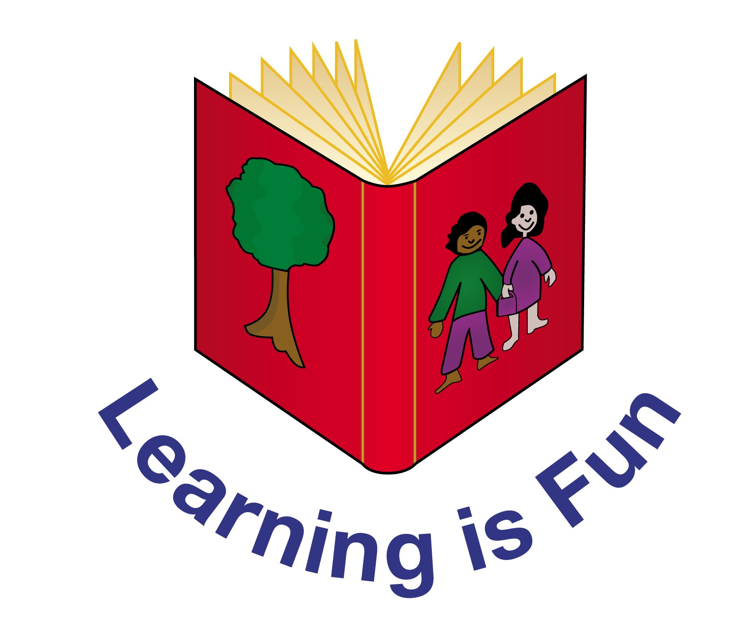

Edith Cavell Primary

RE POLICY

Signed:__G Bishop________________ Chair of Governors

Signed:___H Cooke_____________ Headteacher

Date:___November 2022__________________

Review date:___November 2025 ____________
EDITH CAVELL PRIMARY

RELIGIOUS EDUCATION POLICY

Aims and objectives

At Edith Cavell Primary we develop the children’s knowledge, understanding and application of the major world faiths, and we enhance their spiritual, moral, social and cultural development by developing an awareness of the fundamental questions of life raised by human experiences, and of how religious teaching can relate to them. We enable children to develop a sound knowledge not only of Christianity but also of other world religions, especially those that are the main faiths of children within our school. Children reflect on what it means to have a faith and to develop their own spiritual knowledge and understanding. We help the children learn about religions, understand the impact and make connections between them.

The principal aim of religious education:
The principal aim of RE is to explore what people believe and what difference this makes to how they live, so that pupils can gain the knowledge, understanding and skills needed to handle questions raised by religion and belief, reflecting on their own ideas and ways of living.

This principal aim can be achieved by ensuring the curriculum for RE covers these three main strands.
- Make sense of a range of religious and non-religious beliefs.
- Understand the impact and significance of religious and non-religious beliefs.
- Make connections between religious and non-religious beliefs, concepts, practices and ideas studied.

The legal position of Religious Education
Every pupil has a legal entitlement to RE as part of a ‘broad and balanced curriculum’. Parents have a right to withdraw their child/children from RE.

The religious education curriculum forms an important part of our school’s spiritual, moral and social teaching. It also promotes education for citizenship. Our school RE curriculum is based on the Bedfordshire 2018-2023 Agreed Syllabus and it meets all the requirements set out in that document. RE is a core subject of the curriculum for all pupils. The curriculum time for RE is distinct from the time spent on Collective Worship or assembly. A minimum of 5% of curriculum time is required for teaching RE so that the pupils achieve the standards set out on the syllabus.

Teaching and learning style
We base our teaching and learning style in RE on the three key strands which make up the key principal aims of this subject. All units enable pupils to make sense of the religions and beliefs studied, understand the impact of these beliefs in people’s lives, and to make connections in their learning and their wider experience of the world. Children develop a coherent understanding by studying one religion at a time.

Our teaching and learning styles in RE enable children to build on their own experiences and extend their knowledge and understanding of religious traditions. We use their experiences at religious festivals such as Easter, Diwali, Passover etc. to develop their religious thinking. We organise visits to local places of worship and invite representatives of local religious groups to come into school and talk to the children.

Children carry out research into religious topics. They study particular religious faiths and also compare the religious views of different faith groups on topics such as rites of passage or festivals. Children discuss religious and moral issues using computers and working individually or in groups.

We recognise the fact that all classes in our school have children of widely differing abilities, and so we provide suitable learning opportunities for all children by matching the challenge of the task to the ability of the child. We achieve this in a variety of ways, for example, by:
- setting common tasks which are open-ended and can have a variety of responses;
- setting tasks of increasing difficulty (we do not expect all children to complete all tasks);
- providing resources of different complexity, adapted to the ability of the child;

Curriculum planning in religious education
We plan our religious education curriculum in accordance with the Bedfordshire 2018-2023 Agreed Syllabus. We offer opportunities for children of all abilities to develop their skills and knowledge in each unit, and we ensure that the planned progression built into the scheme of work offers the children an increasing challenge as they move through the school.

The medium-term plans give details of each unit of work for each term. The RE lead keeps and reviews these plans on a regular basis. As we have some mixed-age classes, we carry out the medium-term planning on a two-year rotation cycle. By so doing, we ensure that children have complete coverage of the Agreed Syllabus but do not have to repeat topics. A new unit is taught each half term.

In order to deliver the aims and expected standards of the syllabus, RE is taught for 1 hour per week in both Key Stages.

In Key Stage One children will study in-depth the religious traditions of the following groups: Christians, Jews, and /or Muslims.
In Key Stage Two pupils study Christians, Muslims, Hindus and Jews/ Sikhs.

Foundation Stage
We teach religious education to all children in the school, including those in the reception class.

In reception religious education is an integral part of the topic work covered during the year. As the reception class is part of the Foundation Stage of the National Curriculum, we relate the religious education aspects of the children’s work to the objectives set out in the Early Learning Goals which underpin the curriculum planning for children aged three to five.

Contribution of religious education to the teaching of other subjects

Information and communication technology (Computing)
We use computing where appropriate in religious education. The children find, select and analyse information, using the internet. They also use computing to review, modify and evaluate their work and to improve its presentation. Whenever possible, children are given the opportunity to create presentations based on their learning in relevant units.

Personal, social and health education (PSHE) and citizenship
Through our religious education lessons, we teach the children about the values and moral beliefs that underpin individual choices of behaviour. We also promote the values and attitudes required for citizenship in a democracy by teaching respect for others and the need for personal responsibility. In general, by promoting tolerance and understanding of other people, we enable children to appreciate what it means to be positive members of our multi-faith society.

Spiritual, moral, social and cultural development
Through teaching religious education in our school, we provide opportunities for spiritual development. Children consider and respond to questions concerning the meaning and purpose of life. We help them to recognise the difference between right and wrong through the study of moral and ethical questions. We enhance their social development by helping them to build a sense of identity in a multicultural society. Children explore issues of religious faith and values and, in doing so; they develop their knowledge and understanding of the cultural context of their own lives.

Bible stories are brought to life by regular assemblies led by ‘Open the Book’, a church-based group. These interactive assemblies follow the old and new testament of the bible.

Teaching religious education to children with individual needs
In our school we teach RE to all children, whatever their ability. The teaching of RE is a vital part of our school curriculum, which states that we provide a broad and balanced education for all our children. When teaching RE we ensure that we provide learning opportunities matched to the needs of children with learning difficulties as well as the more able. We take into account the targets set for individual children in their Provision Map and / or EHCP.

Assessment and recording
The three strands for RE set out the knowledge, understanding and application that pupils of different abilities and maturities are expected to have by the end of the Key Stage. Children need to make progress in all of these three strands as they are statutory to the RE syllabus. Each unit provides learning outcomes specific to each question, leading to the end-of-phase outcomes for the three strands. Following the new syllabus guidelines, the children do not need to produce a piece of written work for each lesson. Drama, art, music, role-play, ICT and discussion can form a major part of recording RE. Teachers are able to assess children’s progress and understanding through the school’s internal assessment portal, Insight.

Resources
We keep resources for religious education in a central store. There is a set of bibles for both key stages and a collection of religious artefacts which we use to enrich teaching in religious education. The school library has a good supply of RE topic books and computer software to support the children’s individual research.

Monitoring and review
The RE lead is responsible for monitoring the standards of the children’s work and the quality of the teaching in religious education. They are also responsible for supporting colleagues in the teaching of religious education, for being informed about current developments in the subject, and for providing a strategic lead and direction for the subject in the school. They review samples of the children’s work and visit classes to observe teaching in the subject according to our policy review timetable. The RE lead is able to check each child’s progression via the school’s assessment portal, Insight.

