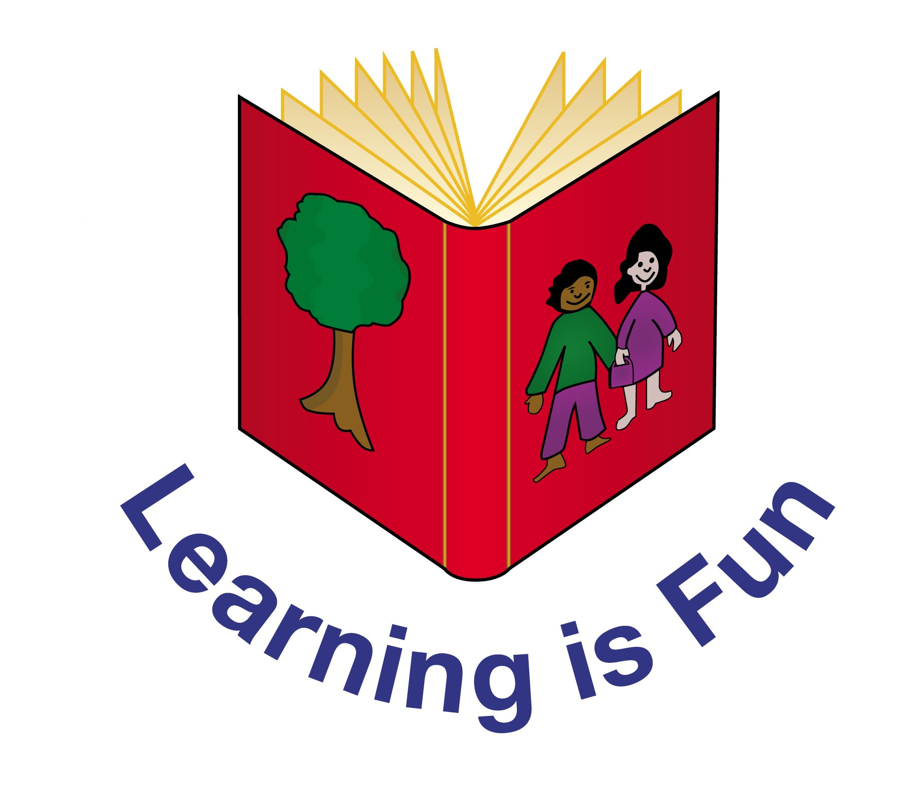

Edith Cavell Primary School

English Policy

Signed:__G Bishop________________ Chair of Governors

Signed:___H Cooke_____________ Headteacher

Date:___July 2022_________________

Review date:__July 2025_____________
EDITH CAVELL PRIMARY SCHOOL

English Policy

Aims of the Policy

English has a pre-eminent place in education and in society. A high quality education in English will teach pupils to speak and write fluently so that they can communicate their ideas and emotions to others and, through their reading and listening, others can communicate with them.

Through reading in particular, pupils have a chance to develop culturally, emotionally, intellectually, socially and spiritually; literature, especially, plays a key role in such development. Reading also enables pupils both to acquire knowledge and to build on what they already know.

The overarching aim for English in The National Curriculum is to promote high standards of language and English by equipping pupils with a strong command of the spoken and written language, and to develop their love of literature through widespread reading for enjoyment. The National Curriculum for English aims to ensure that all pupils:

- Read easily, fluently and with good understanding;
- Develop the habit of reading widely and often, for both pleasure and information;
- Acquire a wide vocabulary, an understanding of grammar and knowledge of linguistic conventions for reading, writing and spoken language;
- Appreciate our rich and varied literary heritage;
- Write clearly, accurately and coherently, adapting their language and style in and for a range of contexts, purposes and audiences;
- Use discussion in order to learn; they should be able to elaborate and explain clearly their understanding and ideas;
- Are competent in the arts of speaking and listening, making formal presentations, demonstrating to others and participating in debate.

At Edith Cavell Primary School, we follow a creative curriculum approach to learning. While appropriate English skills are taught discretely, English is mostly taught through themed work, which allows children to immerse themselves fully into the theme. High quality, theme-based texts are chosen in order to engage the children and spark their enthusiasm for learning, and are sequenced to increase demand over time.
Grammar and spellings are taught both discretely and through our connected curriculum.
We use a variety of teaching and learning styles in English lessons, following our Teaching and Learning policy which stresses creativity and personalised learning. Teaching is precise, tailored to each pupils’ individual starting points. When writing, we follow ‘Talk for Writing’ principles, promoting oracy and the internalisation of text structures prior to innovation and independent writing. Our principal aim is to develop children’s knowledge, skills, and understanding in English and their ability to apply these skills in all areas of learning.

Children will study a range of fiction genres including prose, poetry and plays, and non-fiction texts. They will develop skills in writing for a variety of purposes. As part of their English lessons, children will develop their phonic knowledge, spelling strategies, vocabulary, grammar and punctuation.

Inclusion and Differentiation: (also see SEND policy)
All children are entitled to make good progress in the English curriculum, appropriate to their stage of development. Challenge for all is integral to our teaching and we aim to encourage all pupils to reach their full potential through a well-designed curriculum that is taught well. Work must be differentiated to aid children’s learning from their starting points. Also, high attaining children should be given opportunities for further research and challenging studies.

Statutory Requirements

Statutory requirements for the teaching and learning of English are laid out in the English section of The National Curriculum (2014) and the Statutory Framework for the Early Years Foundation Stage (2021). The teaching and learning of English in EYFS has also been guided by the Development Matters guidance for EYFS document (2021) and the Birth to 5 Matters guidance (2021).

In the Foundation Stage children are given opportunities to:
- Speak and listen and represent ideas in their activities;
- Use communication, language and English in every part of the curriculum;
- Become immersed in an environment rich in print and possibilities for communication.

At Key Stage One children are taught to speak confidently and listen to what others have to say. They will begin to read and write independently and with enthusiasm. They will use language to explore their own experiences and imaginary worlds.

In Key Stage Two children will learn to change the way they speak and write to suit different situations, purposes and audiences. They will read a range of texts and begin to respond to different layers of meaning in them. They should explore the use of language in literary and non-literary texts and learn how the structure of language works.

Assessment and Recording
Formative assessment (teacher assessment) forms the basis of our assessment in English. Summative assessment (tests) are also employed at the end of each term to corroborate formative assessments. Summative assessments for pupils in Years 2 and 6 take the form of ‘SATs’ assessments. In Year 2 SATs, the pupils sit 2 reading papers and a grammar, punctuation and spelling test. This GPaS test is optional for Key Stage 1 to carry out, however we employ this to corroborate and moderate our teacher assessment judgements. In the Year 6 SATs, the pupils sit one reading paper, one spelling test and a grammar and punctuation test. Writing is assessed in both Years 2 and 6 against the Teacher Assessment Frameworks (2018-19), which are then moderated across key stages, whole-school and local schools. All year groups also assess independent writing each half term against the KPIs, whilst having an understanding of the criteria of the Teacher Assessment Frameworks (TAFs).

Formative assessment is made on a daily basis and planning is adjusted accordingly to meet the pupils’ changing needs. Assessments are closely matched to the teaching objectives.

The Governing Body

Regular reports are made to the Governor body on the progress of English within the school.

Subject Organisation

The English Curriculum is delivered following The National Curriculum (England 2014). The Early Learning Goals are followed to ensure continuity and progression from the Foundation Stage through to the National Curriculum.

Reading
The programmes of study for reading at Key Stages 1 and 2 consist of two dimensions:
- Word reading
- Comprehension (both listening and reading).
Writing
The programmes of study for writing at Key Stages 1 and 2 are constructed as follows:
- Transcription (spelling and handwriting)
- Composition (articulating ideas and structuring them in speech and writing).

Teaching will aim to develop pupils’ competence in these two dimensions. In addition, pupils will be taught how to plan, revise and evaluate their writing.

Spelling, vocabulary, grammar and punctuation

Opportunity for teachers to enhance pupils’ vocabulary arise from the teaching of reading and writing. As vocabulary increases, children will be encouraged to understand the relationships between words, how to understand nuances in meaning and how to develop their understanding of, and ability to use, figurative language.

Cross-Curricular English Opportunities

Teachers will seek to take advantage of opportunities to make cross-curricular links. They will plan for pupils to practise and apply the skills, knowledge and understanding acquired through English lessons to other areas of the curriculum. A high standard of English is embedded within the curriculum and is at the heart of all learning.

Opportunities to use ICT to support teaching and learning in English will be planned for and used as appropriate.

Role of Subject Leader

The Subject Leader is responsible for monitoring the standards of teaching and ensuring high standards of English taught through:

Monitoring and evaluating English:

- Pupil progress;
- Provision of English (including intervention and support programmes);
- The quality of the learning environment;
- Taking the lead in policy development;
- Auditing and supporting colleagues in their CPD;
- Purchasing and organising resources;
- Keeping up to date with recent English developments.

Related Policies

This policy also needs to be in line with other school polices and therefore should be read in conjunction with the following:

- Teaching and Learning Policy
- Assessment Policy
- Marking Policy
- SEND Policy

Appendix 1- Handwriting Policy

School Aims

We aim for our pupils to develop a neat, legible, speedy handwriting style using continuous cursive letters that leads to producing letters and words automatically in independent writing.
An effective handwriting policy is based on a style that is quick and easy to learn. It should be neat, legible and fast. Pupils should eventually develop the ability to produce letters intuitively. An automatic style releases the brain to concentrate on other ideas i.e. spelling, grammar, syntax, style and content. At Edith Cavell Primary School, we use a continuous cursive style of handwriting to support our teaching of handwriting. Handwriting should be taught according to the letter families, and phonic and spelling knowledge should be reinforced during handwriting lessons.

Consistency Throughout the School

Pupils should experience coherence and continuity in the teaching and learning of handwriting across all school years, and should be encouraged to take pride in the presentation of their work. Our aim is to help pupils enjoy learning handwriting skills so that they can feel a sense of achievement around their written work.

Resources

The teaching of handwriting is supported by the use of the following website; http://www.teachhandwriting.co.uk/ . This website provides resources to support the learning of continuous cursive handwriting and is accessible to all staff, children, parents and carers.

Once pupils are writing single letters neatly, confidently and legibly, they move on to joining letters (which is expected by the start of Year 2). Pupils then follow the school handwriting scheme, which was created by the English Lead. This scheme is readily available on the Shared Drive and is centred around teaching (in a specified order) each of the individual joins for each of the handwriting letter families. Pupils are first exposed to the Long Ladder Letter family, then the One-Armed Robot Family, the Curly Caterpillar family and the Zig Zag Monster family. After each family is introduced, pupils practise joins from this family, in addition to previously taught families, to reinforce learning.

During each handwriting lesson, pupils practise the targeted letter join, then practise a ‘real’ or a ‘nonsense’ word containing that join. This word only contains letter joins previously taught. Pupils then practise writing common exception word spellings containing the targeted join. The KS1, LKS2 and UKS2 Common Exception Words are all displayed, enabling pupils to reinforce prior spelling knowledge at the same time as practising their joined handwriting.

Handwriting Skill

The skill of handwriting needs to be taught. Handwriting is a motor activity; a movement stored in the body rather than in the conscious memory. Our hands and fingers control the movements involved in handwriting. It is within our hands that the kinaesthetic memory lies. This controls the direction and shape of each letter.
Effective teaching of handwriting can only be achieved through modelling. At Edith Cavell Primary School, teachers demonstrate letter formation and joins regularly, and children practice by carefully copying and repeating. It is important to observe children writing to ensure they are forming letters correctly, starting and finishing in the correct place. It is also important to check that pupils are holding a pencil or a pen correctly.

Handwriting Principles

-Handwriting is taught daily in the first two weeks of the academic year to enable pupils to reactivate the fine motor skills and muscles needed to write neatly and legibly.

-Handwriting is taught explicitly, in short, twice-weekly sessions. It is modelled by the teacher then supervised.

- Common Exception Word spellings are linked to each handwriting join. This helps with handwriting and with the ‘muscle memory’ of spellings.

- Teachers model good handwriting at all times, e.g. when writing on the whiteboard and when marking books.

Handwriting in the Foundation Stage (Nursery)

Good handwriting relies on secure motor control and hand-eye coordination. Children in the Foundation Stage should learn handwriting through movement with the actual writing of letters as the ultimate aim. Children will:
- Engage in activities requiring hand-eye coordination
- Use one-handed tools and equipment
- Draw lines and circles using gross motor movement
- Manipulate objects with increasing control
- Begin to use anticlockwise movement and retrace vertical lines
- Begin to form recognisable letters
- Use a pencil and hold it effectively to form recognisable letters, most of
which are correctly formed.

Throughout the Foundation Stage, children will have copious opportunities to develop:

- Physical control, through large-scale movements such as balancing, climbing, marching and moving to music.

- Manipulative skills, through using tools, cooking utensils and scissors.
- Fine motor control and hand-eye coordination, through activities such as jigsaws, threading, cutting and manipulating ‘small world’ equipment.

The key movements underpinning letter formation should be introduced through large-scale movements, from the shoulder.
In the earliest stages, children should make the movements symmetrically using both arms. Once the movement is firmly established in kinaesthetic memory, it can be reduced in scale using activities such as sky writing, using sticks in sand etc. and then reduced further in art activities using felt tip pens, crayons and chubby pencils.

Handwriting in the Foundation Stage (Reception)

Handwriting in Reception focuses on:
- Pre-writing stage- patterning
- Individual letter formation
- Word formation based on the handwriting families.
Pupils also have the opportunity to practise their letter formation throughout twice-daily Sounds-Write phonic lessons, where the emphasis is on applying sounds to writing.

Handwriting Progression

The National Curriculum English Programmes of Study provide guidance on teaching handwriting:
Year 1 pupils should be taught to:
- Sit correctly at a table, holding a pencil comfortably and correctly
- Begin to form lower-case letters in the correct direction, starting and finishing in the right place

- Form capital letters
- Form digits 0-9
- Understand which letters belong to which handwriting ‘families’ (i.e. letters that are formed in similar ways) and to practise these
- Make links with phonics and spelling

Year 2 pupils should be taught to:
- Form lower-case letters of the correct size relative to one another
- Start using some of the diagonal and horizontal strokes needed to join letters and understand which letters, when adjacent to one another, are best left not joined

- Write capital letters and digits of the correct size, orientation and relationship to one another and to lower case letters

- Use spacing between words that reflects the size of the letters

Year 3-4 pupils should be taught to:
- Use the diagonal and horizontal strokes that are needed to join letters and understand which letters, when adjacent to one another, are best left not joined

- Increase the legibility, consistency and quality of their handwriting, e.g. by ensuring that the down strokes of letters are parallel and equidistant; and that lines of writing are spaced sufficiently so that the ascenders and descenders of letters do not touch

Year 5-6 pupils should be taught to:
- Write legibly, fluently, with increasing speed and personal style by:
- Choosing which shape of a letter to use when given choices and deciding, as part of their personal style, whether or not to join specific letters

- Choosing the writing implement that is best suited for a task (e.g. quick notes, letters)

Continuous Cursive: Joining Handwriting

At Edith Cavell Primary School, we introduce joined up handwriting at an early stage of a child’s development: from Year 1 onwards.
Learning a series of early rhythmical movements can help children with specific learning difficulties improve their fine motor coordination.

There are many benefits to using a continuous cursive joined handwriting style:

- The starting and finishing points for all the letters are easier to remember (they all start on the line and, other than a few exceptions, all finish on the line)

- Children are able to write at a faster pace

- Lessens the chance of reversing letters

- Spaces between words become more obvious

- Upper and lower case letters are clearer

- The child only has to learn one style of writing

-The transition to joined writing is simple and occurs sooner

- It aids the flow of the writing as the letters naturally provide a left-to- right directional movement. This rhythmical flow also aids speed and fluency.

- Many children with specific learning difficulties find the continuous cursive font style easier to learn and it is often recommended by specialist teachers, educational psychologists and is used in dyslexic-friendly schools.

- Words are written in one set of movements without the pen being taken off the paper, this helps the motor memory to store spellings. This is especially important for irregular spellings that can be hard to commit to memory.

Differentiation

- All children should be encouraged to use the correct pencil grip and sit with a good posture.

- Left-handed children should sit to the left of right-handed children to avoid their writing arms from bumping each other. The angle of the paper depends on the handedness of the pupil. Left-handed children should sit with their body and paper at a slant to the right. This enables them to see their pencil tip, prevents them smudging their work with their writing hand and allows the pencil to move more freely. A left-handed writer may also benefit from holding the pencil higher up.

- Children whose handwriting is limited by problems with fine motor skills, including left-handed children, and children with special educational needs, will be given additional support. Additional
resources may also be used (i.e. a writing slant).

