Schools Financial Benchmarking
https://schools-financial-benchmarking.service.gov.uk/School/Detail?urn=109433
The financial benchmarking service from the DfE allows us to make comparisons between other schools similar to ourselves. We can compare across 4 main areas:
- Expenditure
- Income
- Balance
- Workforce
Within these areas there are charts covering more specific aspects. For example, you can see charts focusing on expenditure is areas such as:
- Staff
- Premises
- Supplies & service
The current data is based on 2019-20
On our benchmarking report some of our cost are showing as significantly higher than other schools in 2019-20.
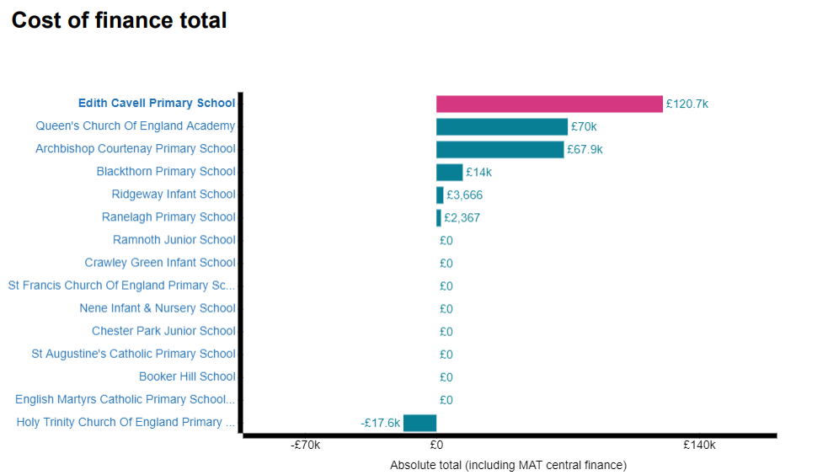
£120.7K this is being to due considerable renovation to the school. This included a complete refurbishment to our Reception block which included new internal ceilings, new flooring, repaint and new resources. We also had new internal acoustic internal ceiling installed in our blue classroom.
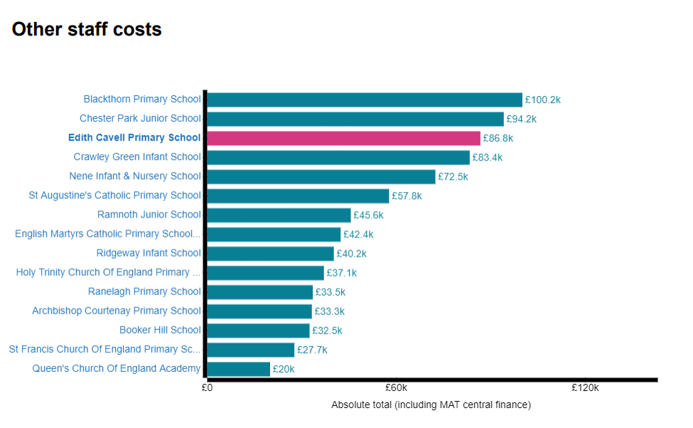
These cost include employer our own internal IT technician rather than outsourcing this level of support.

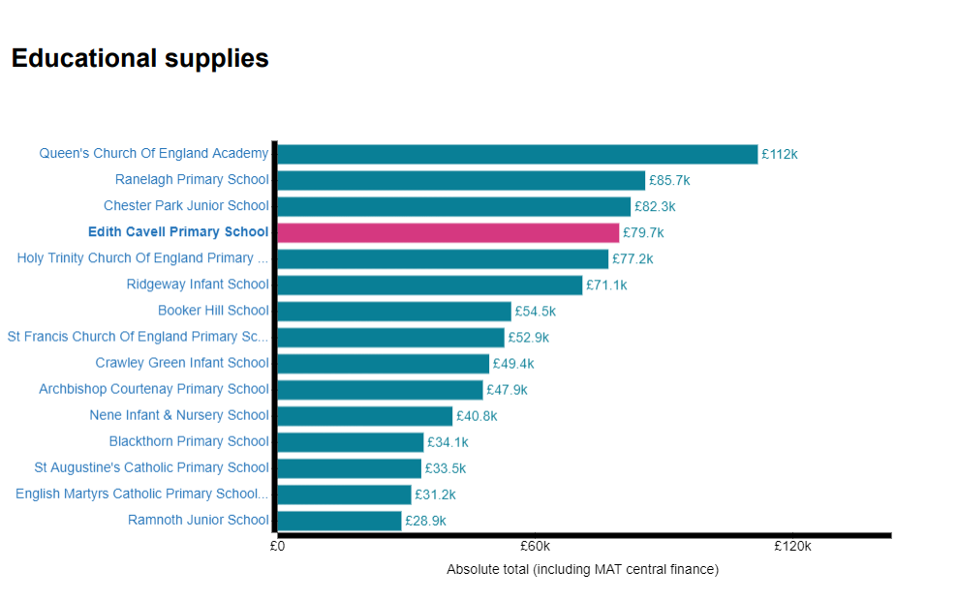
These cost include the new resources for our newly refurbished Reception block.
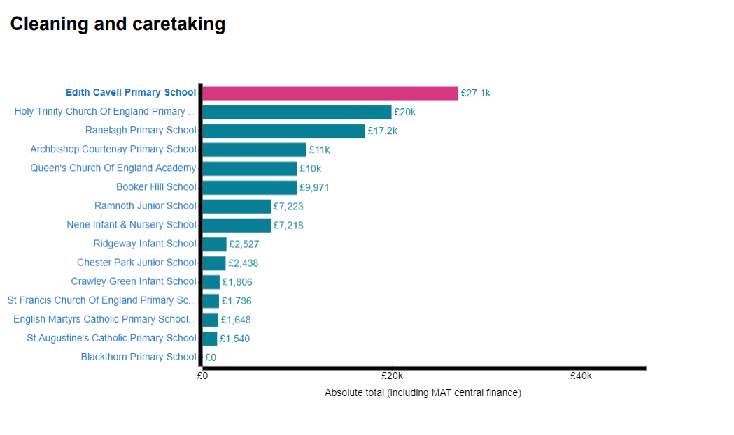
These cost are higher because we use an external cleaning company. Within these costs the majority of the cleaning supplies are included.

