MATHEMATICS  The focus for mathematics in EYFS is on practical experiences and understanding. Children will have experience of counting in lots of different situations, practically adding and taking away and using these skills to solve simple problems. Children will explore 2D and 3D shapes and their similarities and differences. They will compare and order objects by length, size and weight.  UNDERSTANDING THE WORLD  Throughout the year the children will observe our environment and the changes that occur. We look at similarities and differences between ourselves and others. We will learn about different celebrations from different cultures and the different groups we belong to. Technology also plays a part in this area of the curriculum. Children will have access to different devices such as the iPads, programmable toys and the computers. | OUTDOOR LEARNING  The children have daily access to our outdoor area to continue their learning. All children should keep a pair of wellington boots in school for going outside.  TOPICS  Our curriculum is taught through the following topics –  Autumn – An Autumn Harvest and Light and Dark  Spring – Winter wonderland and Superheroes  Summer – Big and Little and Summer Fun.  EXPRESSIVE ARTS AND DESIGN  The children are encouraged to use their imagination through their play, drama, music and art work. The children have daily access to painting and model making. They are taught to mix their own colours and to wash up after themselves. Children will be taught a range of songs relating to their topics throughout the year. |  | EYFS  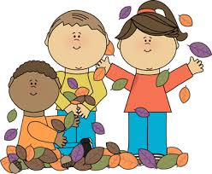  Amber Class  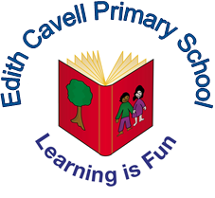  Edith Cavell Primary School  01234 345636 www.edithcavellprimary.co.uk.  Email office@ecls.org.uk

Our Curriculum  The early years curriculum focuses on the development of the whole child providing them with the skills and experiences needed to achieve a good level of development by the end of the reception year. It is broken down into 7 areas of learning –  - Communication and Language  - Physical Development  - Personal, Social and Emotional Development  - Literacy  - Mathematics  - Understanding the World  - Expressive Arts and Design.  Children in EYFS learn best by playing and exploring, being active and through creative and critical thinking which takes place indoors and outdoors.  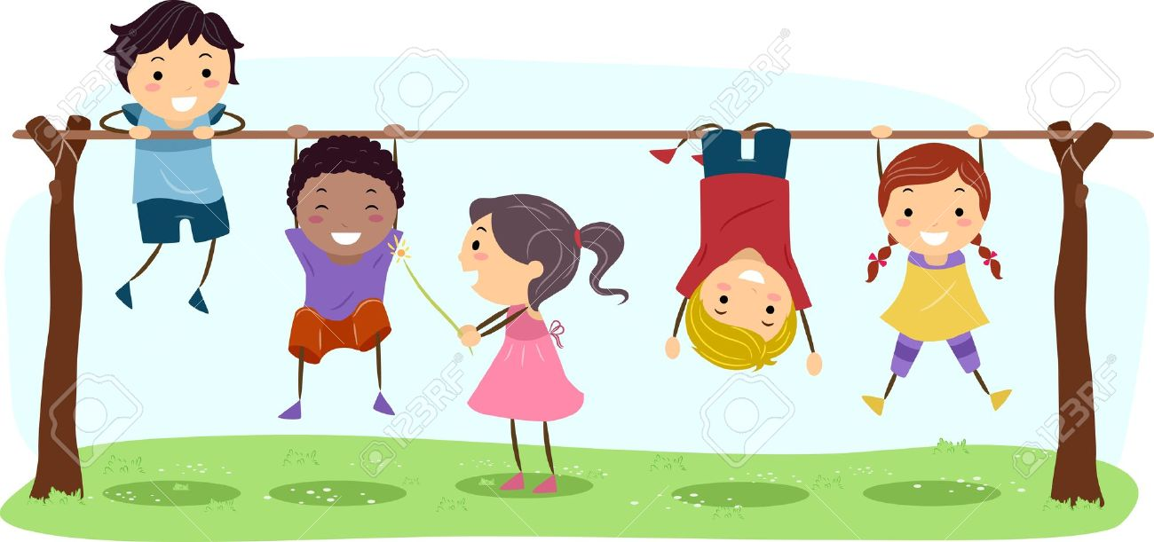 | COMMUNICATION AND LANGUAGE  Being able to communicate is a life skill. Over the year the children are encouraged to talk about everything! This might be done through role play, during whole class circle time, story telling, working with a partner to solve a problem or just a one to one conversation with an adult. Talking is a prerequisite for writing, if the children cannot say it then they will be unable to write it. As well as talking it is important that they develop their listening skills and their ability to follow instructions.  PERSONAL, SOCIAL AND EMOTIONAL DEVELOPMENT  This is such an important area and our main focus of the curriculum, especially during the Autumn Term whilst we are settling the children. Happy children make successful learners. We teach the children about managing their own feelings and being aware of each others. They will learn how to share, take turns and find compromises. We encourage children to try things for themselves and not to give up if they are not successful on their first attempt. | PHYSICAL DEVELOPMENT  Throughout the year we focus on developing children’s gross and fine motor skills. Gross motor skills include kicking and throwing a ball, balancing, jumping and riding bikes. Fine motor skills include cutting and using a pencil. Children have access to our outdoor area throughout the day. We have a weekly PE session in the school hall where we learn about getting changed, spatial awareness, and practice different activities to develop our hand eye coordination and listening skills.  LITERACY  We follow the sounds write scheme for phonics, which teaches the children the different sounds and the different ways we write them. We teach the children to read and spell cvc words and this is consolidated with their reading books which all require phonic knowledge to decode the words. Lots of mark making activities are included in our role play area and outside on clipboards and with pots of water and brushes and chalks.

